**Exercise 1**

**Part 1. Clone your Submission Repo and create a directory structure.**

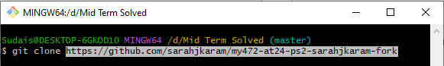

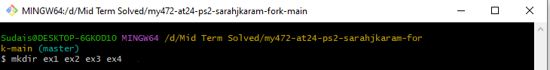

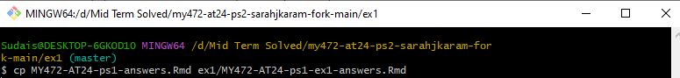

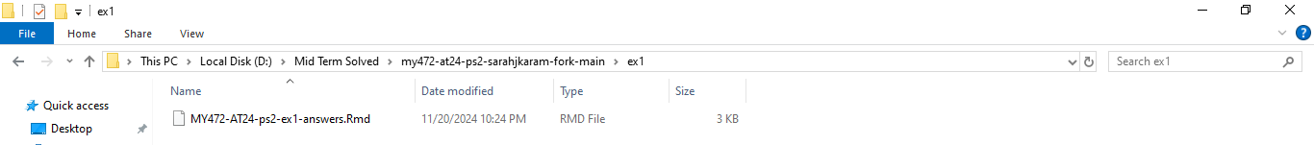

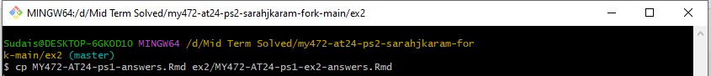

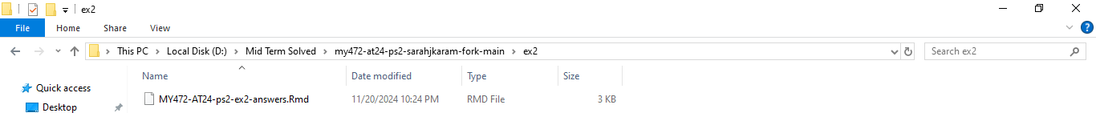

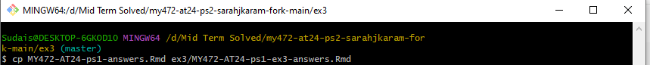

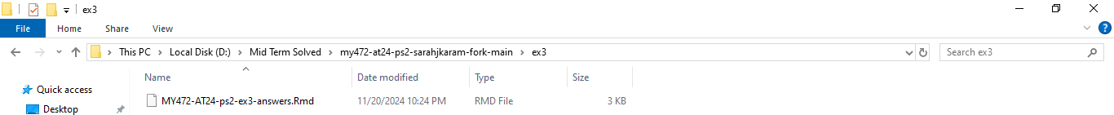

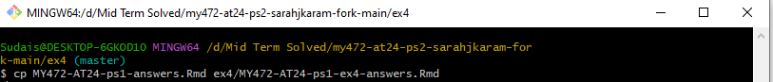

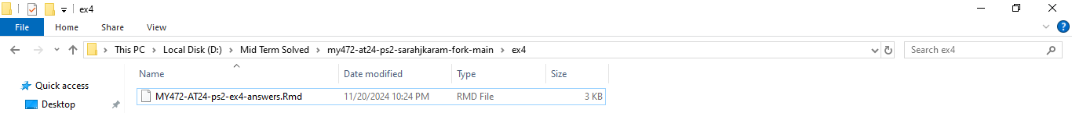

**Part 2: Generate a Screenshot**

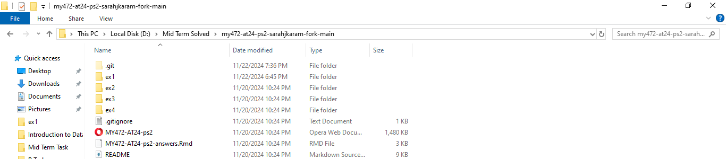

**Part 3. Figure out character encoding**

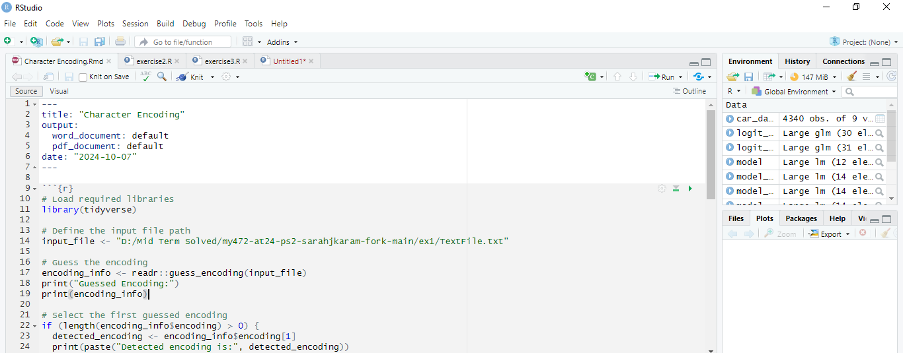

**R Mark Down**

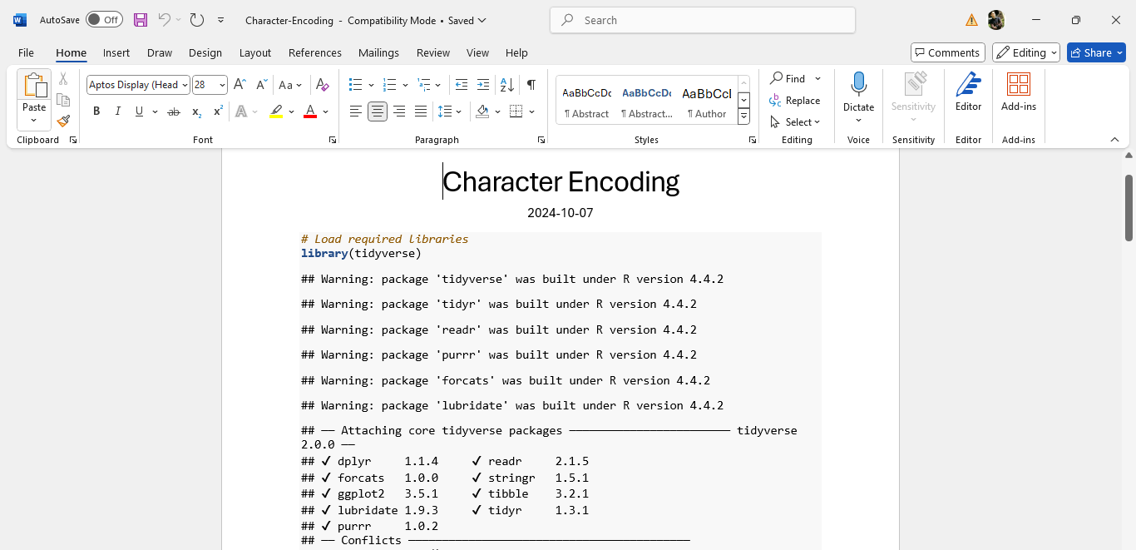

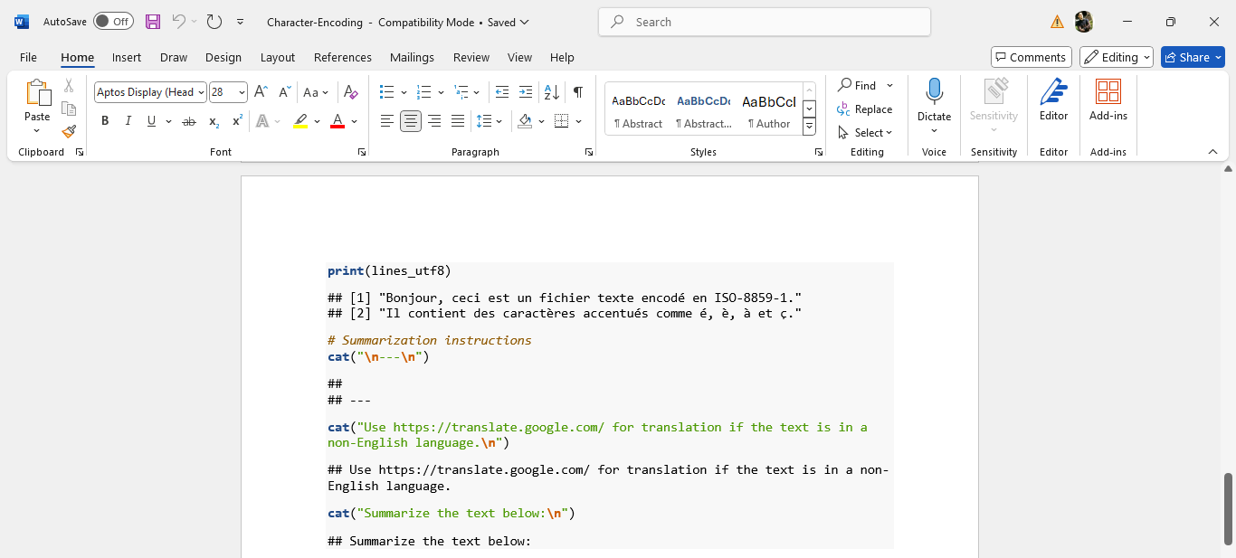

**Exercise 2**

**Part 1. Create dataset of all major presidential candidates since the 1952 election.**

**And Part 2. Create dataset of all U.S. senators since January 1953.**

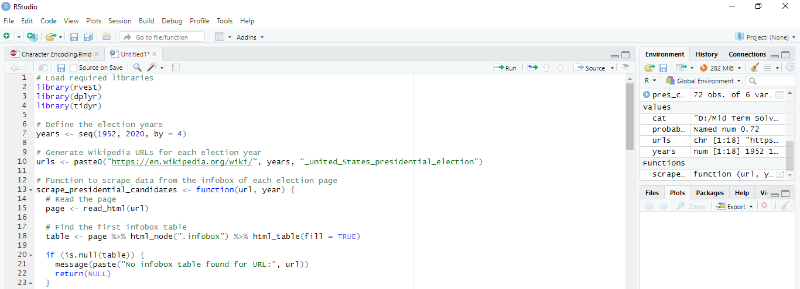

**Exercise 3**

**Part 1. Get data and explore**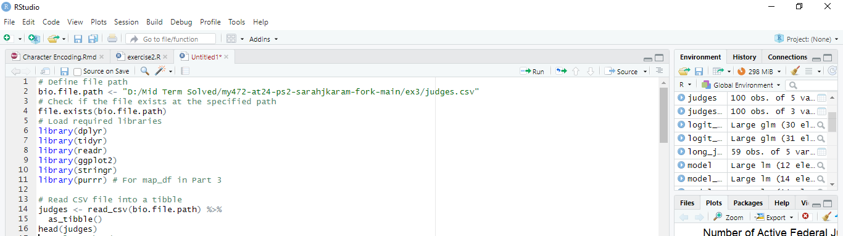

**Part 2. How many judges have multiple appointments?**

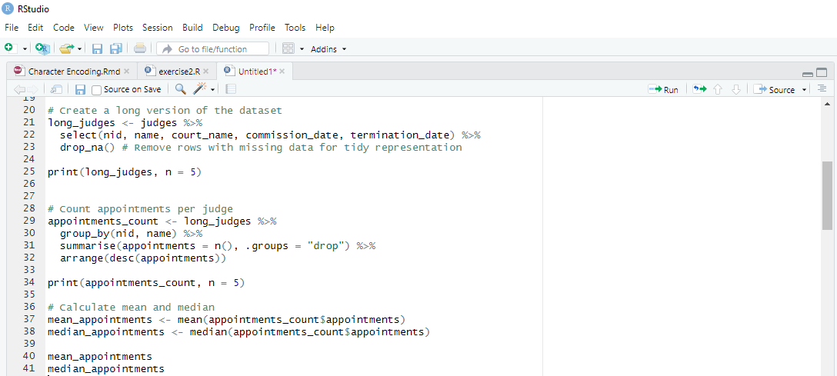

**Part 3. How many federal judges have there been over time?**

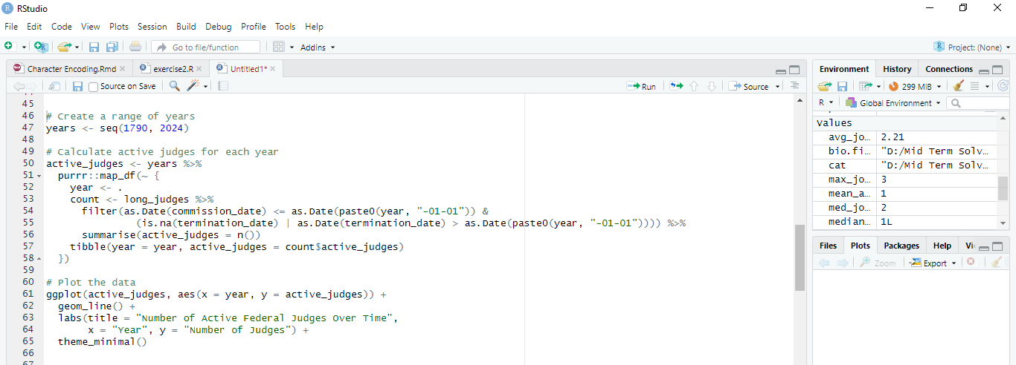

**Part 4. Exploring judges' previous careers**

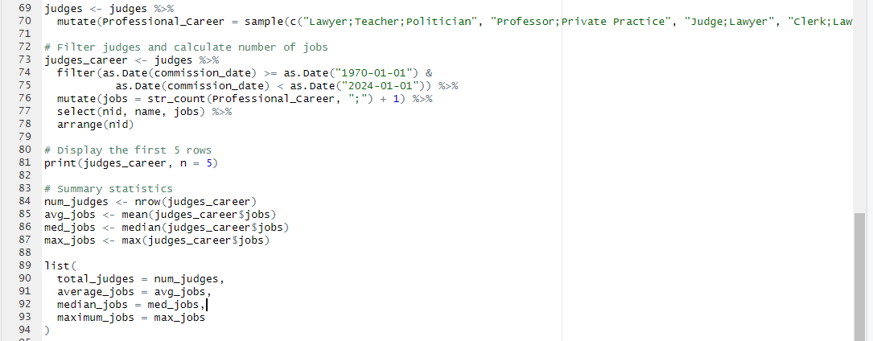

**Exercise 4**

**Part 1. Launch the browser and find hearings from the 117th Congress**

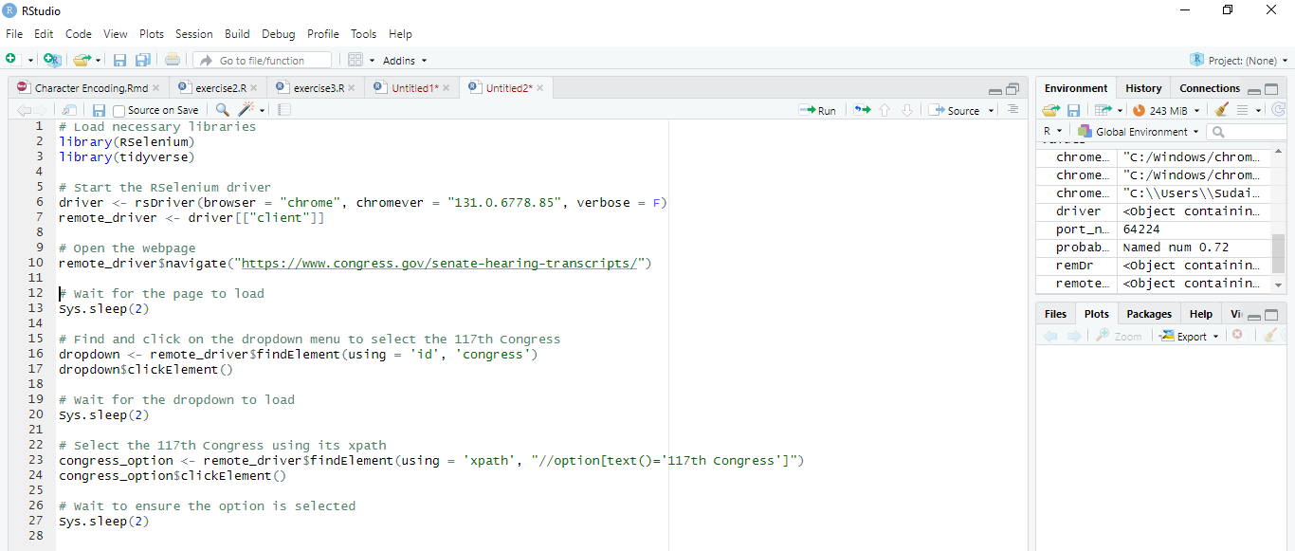

**Part 2. Create a table of the Senate hearings from the 117th Congress**

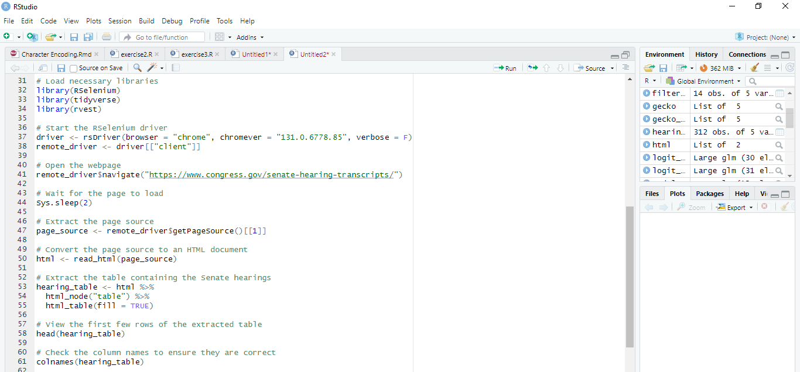

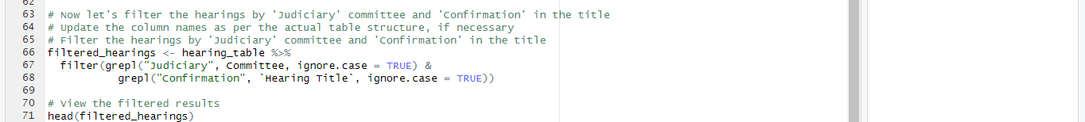

**Part 3. Get the transcript from each hearing about judicial nominations**

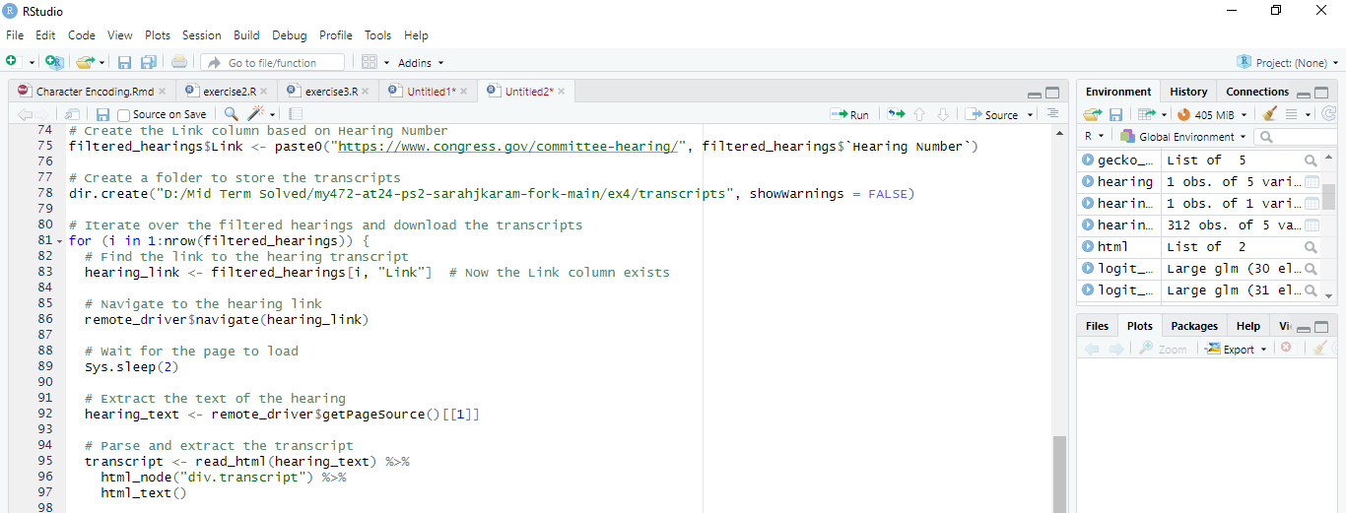



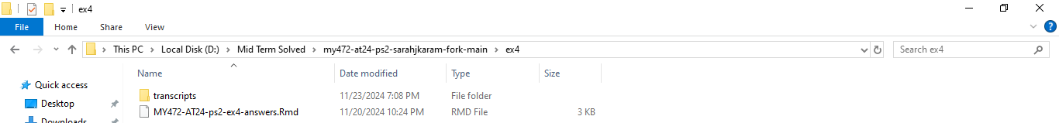

**Part 4. Create a dfm**



